Maven Lifecycle -- Phases -- Plugin -- Goals

maven lifecycle --> maven lifecycle is associated with different phases

phases --> each phase will have plugin

plugin --> plugin will be associated with one or more goals.

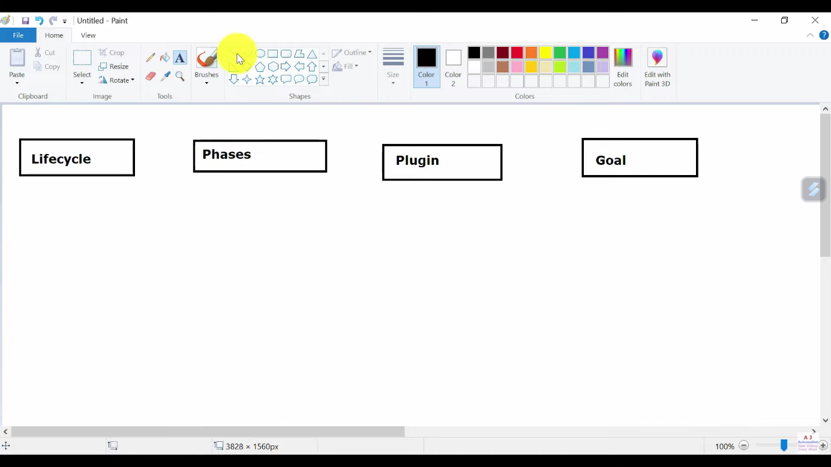

--------------------------------------------------------------------------------------------------------------------------------------------------------------------------------------------

maven lifecycle has 3 phases :

1. maven build /default lifecycle

Lifecycle default/ Build Lifecycle - [validate, initialize, generate-sources, process-sources,

generate-resources, process-resources, compile, process-classes,

generate-test-sources, process-test-sources, generate-test-resources,

process-test-resources, test-compile, process-test-classes, test,

prepare-package, package, pre-integration-test, integration-test,

post-integration-test, verify, install, deploy]

2. maven clean lifecycle

Lifecycle clean - [pre-clean, clean, post-clean]

Clean Lifecycle have 3 phases:

1. Pre Clean: In this some process which are required prior to Clean phase are executed.

2. Clean : In this , we actually clean the multiple files in the target folders generated in Previous Build. This can include few temporary files, project JARs, Source files and compiled classes

This is required so that we get fresh build.

3. Post Clean: In this , few processes executes to finalize cleaning of the Project.

Here main phase is the Clean phase. Build Lifecycle is used to compile, Execute testcases and create Project JAR.

Means we will clean our project first with mvn clean so that we will get fresh build after running mvn install.

3. maven site lifecycle

Lifecycle site - [pre-site, site, post-site, site-deploy]

The flow is sequential, phases runs one after another step by step,

Ex-for default lifecycle, it starts with validate, then initialize and so on...

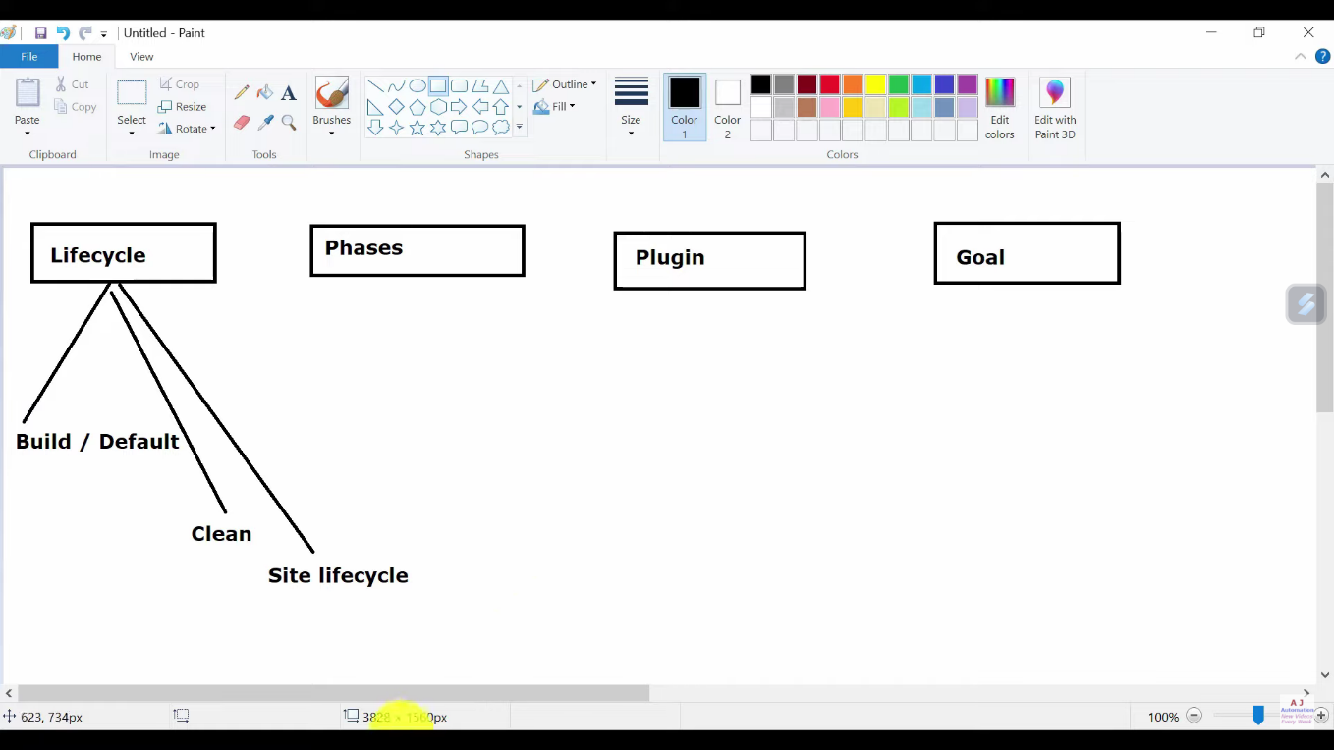

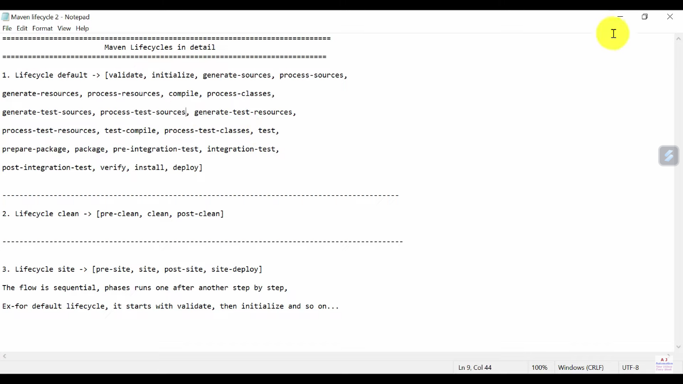

--------------------------------------------------------------------------------------------------------------------------------------------------------------------------------------------

Phases lo different phases untai avi entantea

validate

compile

test

packaging

install

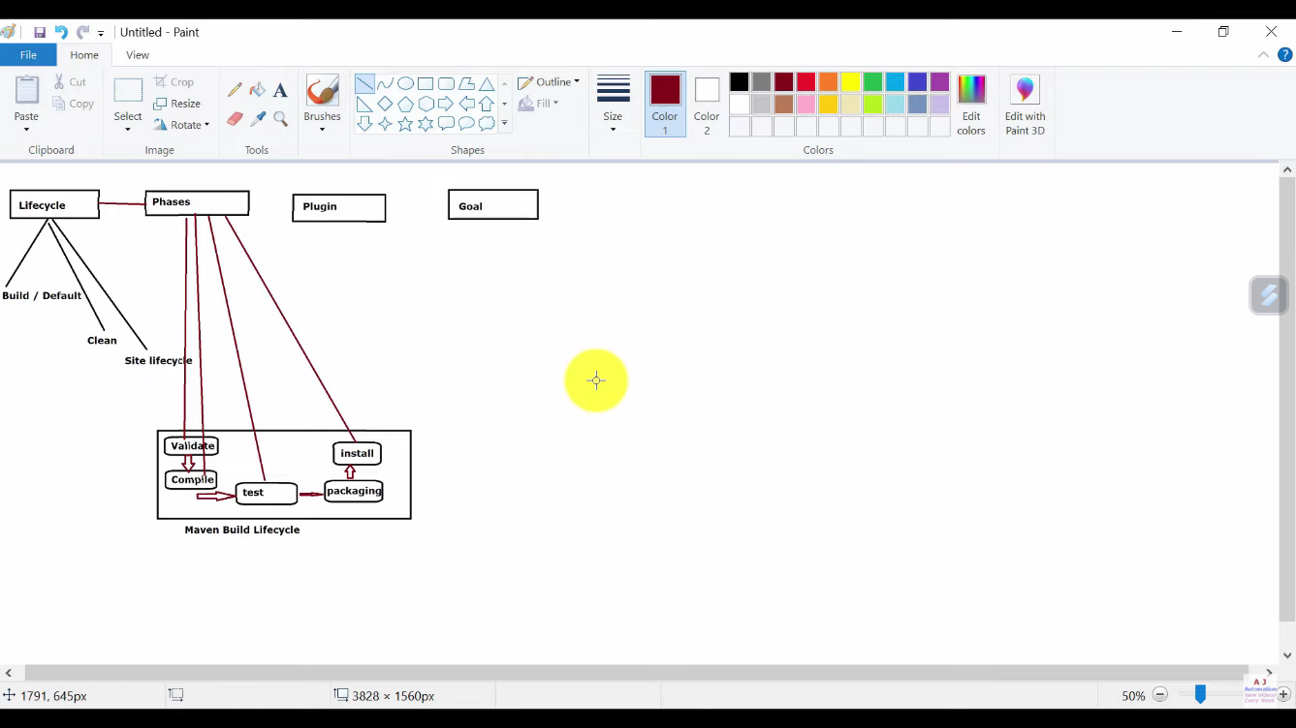

--------------------------------------------------------------------------------------------------------------------------------------------------------------------------------------------

Plugin ala use aavutai antea

compile cheaseatapudu compiler plugin use chestamu

test cheaseatapudu surefire plugin use chestamu

packaging cheaseatapudu jar plugin use chestamu

install cheaseatapudu install plugin use chestamu

clean cheaseatapudu clean plugin use chestamu

validate cheaseatapudu resourse plugin use chestamu

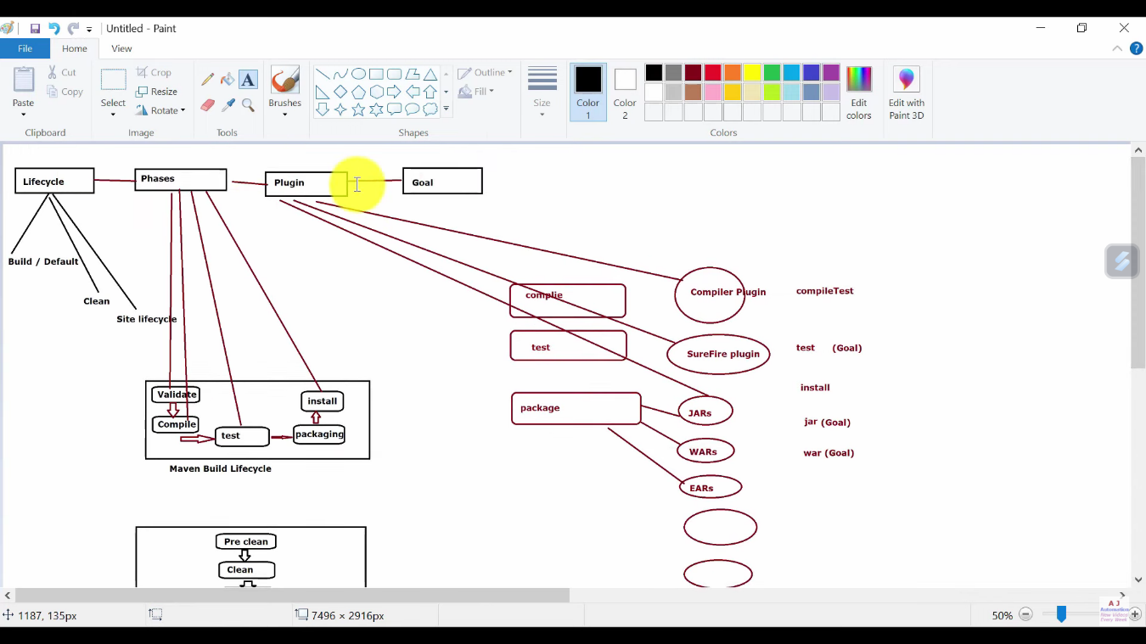

--------------------------------------------------------------------------------------------------------------------------------------------------------------------------------------------

Goal ala use aavutai antea

mvn phaseName

mvn plugin:goal

mvn phase1 phase2

mvn compile (or) mvn compiler:compile --> this will run all the previous phases upto the compile phase

mvn test --> this will run all the previous phases upto the test phase

mvn install --> this will run all the previous phases upto the install phase

mvn clean --> this will run all the previous phases upto the clean phase

